Analytics with ORM Stack

Contents

1. Introduction 3
2. Workflow diagram to deploy the stack 3
3. Create stack for the Analytics “Default Domain” 4
4. Plan the Job 7
5. Apply the Job 8
6. Verify in the Console 9
7. Destroy the stack 10

Introduction

Analytics empowers business analysts and consumers with modern, AI-powered, self-service analytics capabilities for data preparation, visualization, enterprise reporting, augmented analysis, and natural language processing.
In the context of OCI (Oracle Cloud Infrastructure), analytics refers to the process of gathering, analyzing, and deriving insights from data within the OCI environment. OCI provides several services and tools that enable organizations to perform analytics on their data.

Workflow diagram to deploy the stack
Below diagram shows how the Terraform Artifact are applied in the OCI. While creating a ORM stack, using terraform deliverables Init, Plan and Apply is the flow to provision the resource in the OCI. We can have the deliverables in any of below.
- GitLab/GitHub Repo
- Bitbucket
- Can be in folder/.zip in the local disk
- Object Storage Bucket
- Can be in compartment
- Oracle provided Template

Pre request:
- IDCS Access token

Create stack for the Analytics “Default Domain”

Go to OCI Console Developer Services Resource Manager Stacks select the compartment Create Stack

My Configuration Folder Browse Select the “analytics” folder that contains the terraform Upload

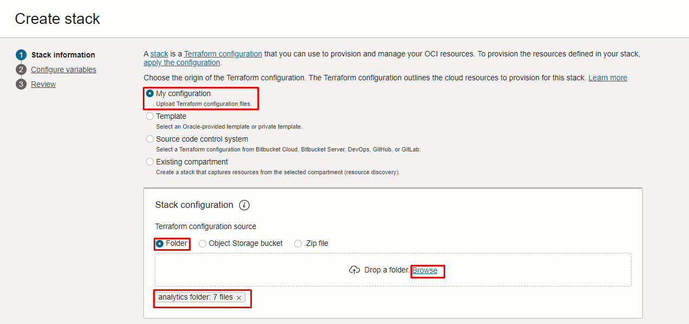

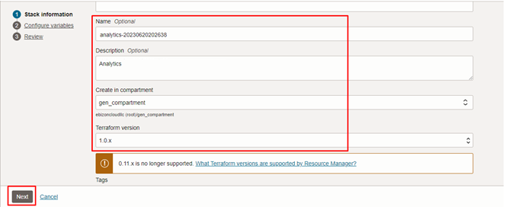

Click “NEXT”

Select the parameters as per the below screen,
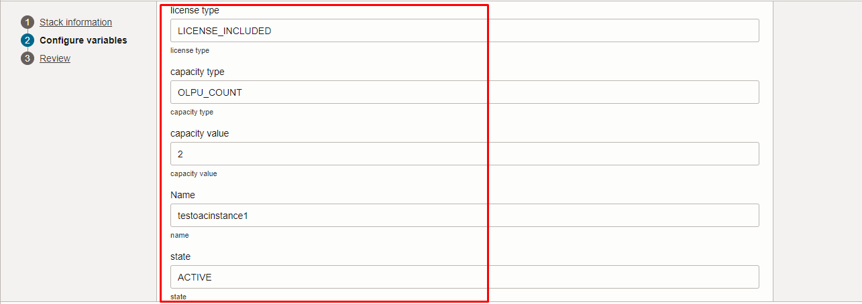
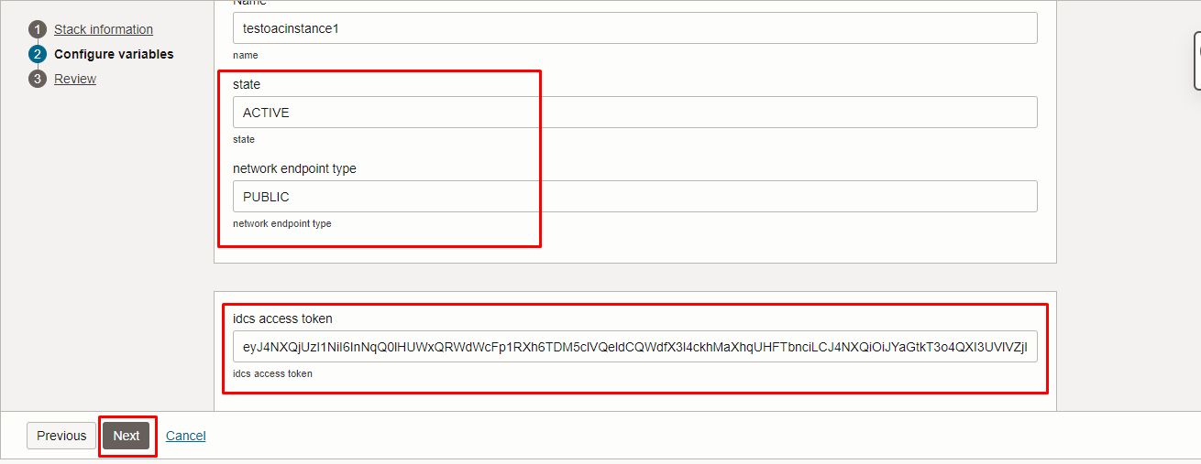

Click “NEXT” Click “CREATE”

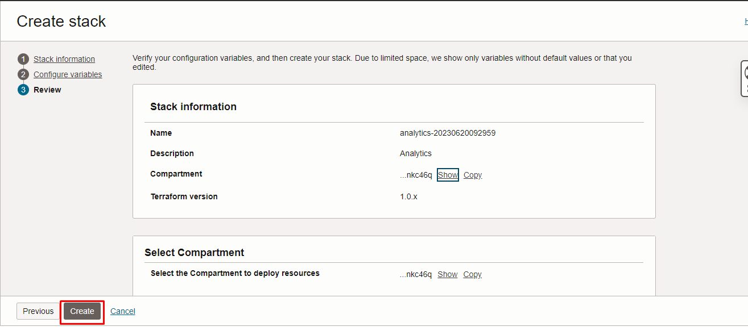

Plan the Job

Click the “Plan”

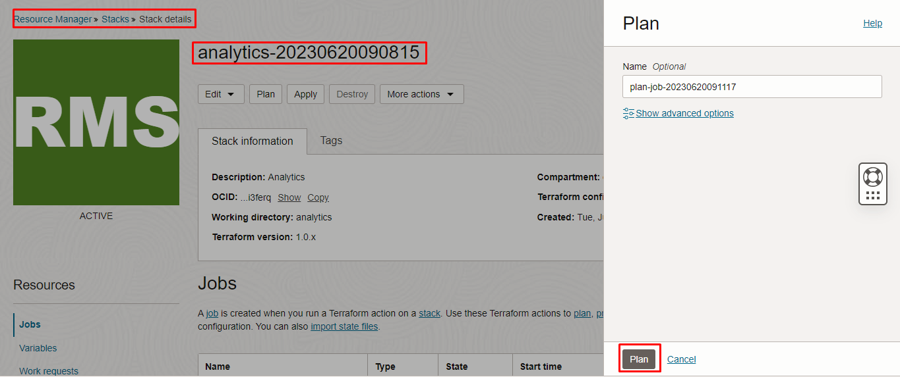

Verify the Plan is successful.

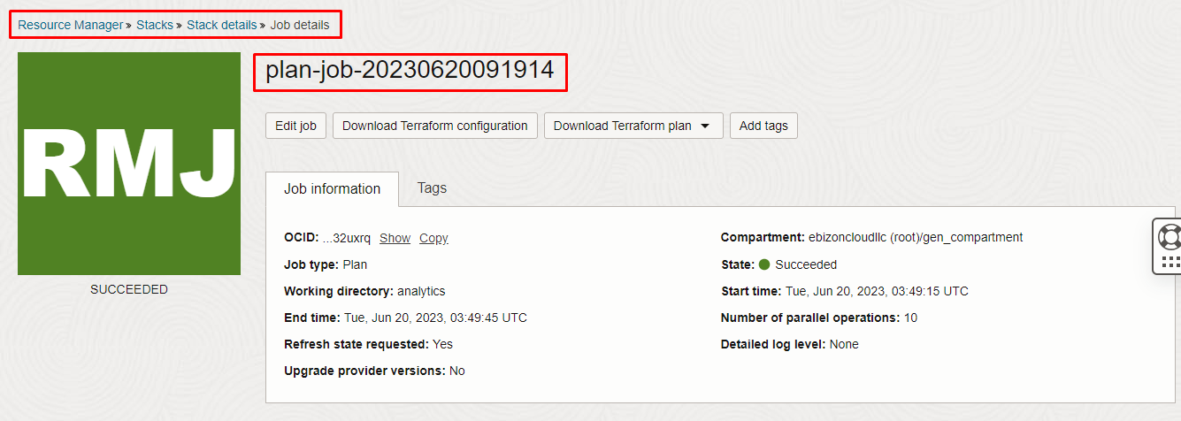

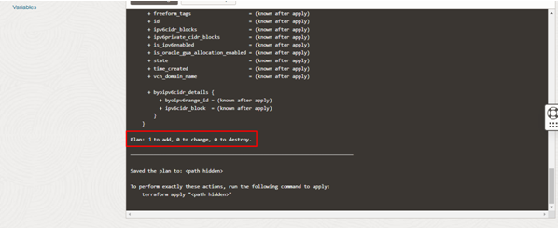

Apply the Job

Once the “plan” is success, now click “Apply”

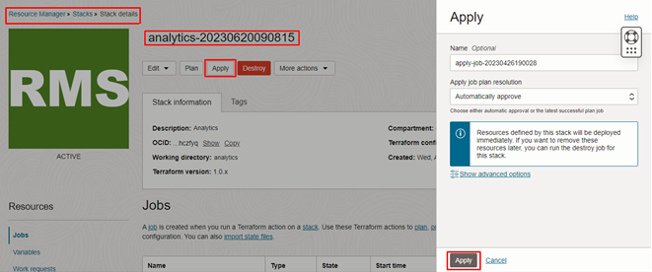
Verify the Apply is successful.

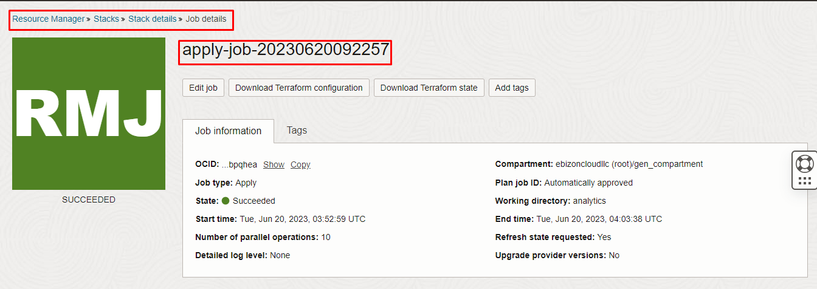

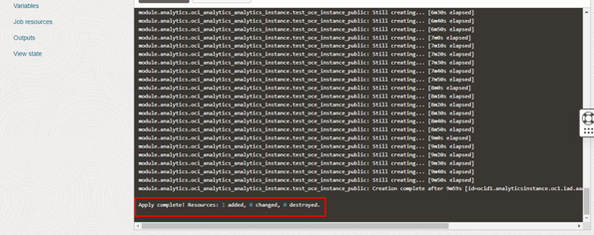

Verify in the Console

Go to OCI Console Analytics & AI Analytics

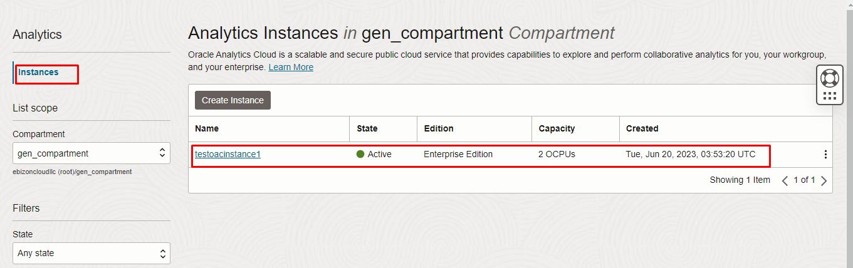
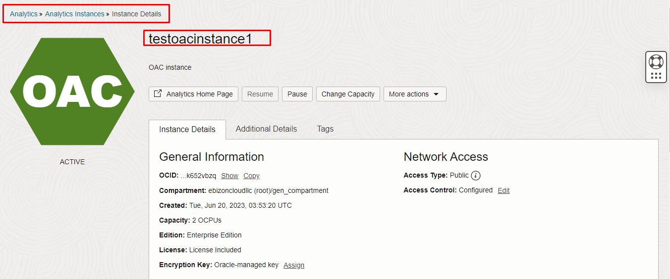
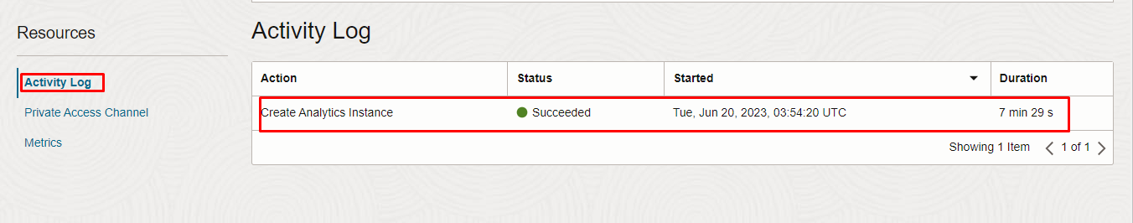

Destroy the stack

Create a destroy job in Resource Manager to release resources associated with a stack and clean up the tenancy. Once destroyed data cannot be recovered from resources.

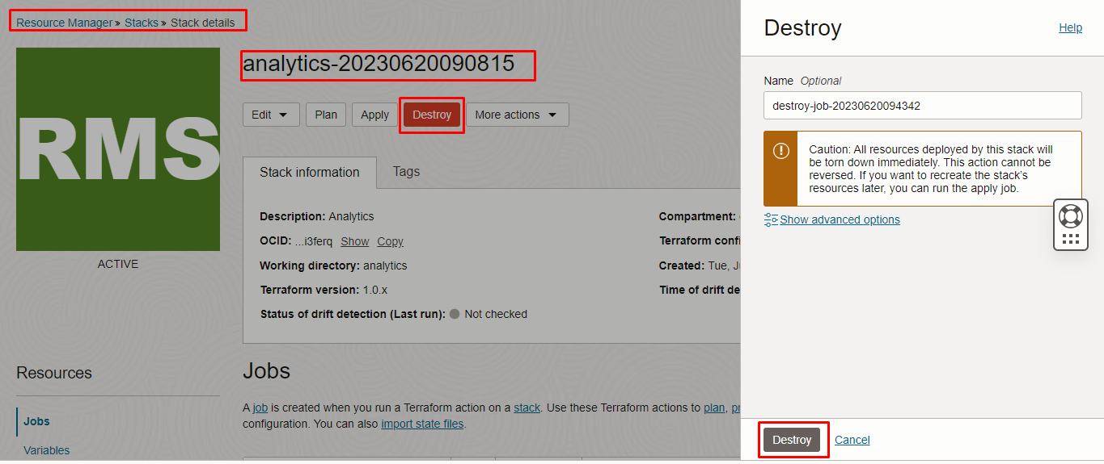

#####END#####

